**There are three issues**

1. **Student dashboard is missing.**

**Once student logins, only three options are coming “SETTINGS, NOTIFICATIONS, LOGOUT”. COURSES is missing.**

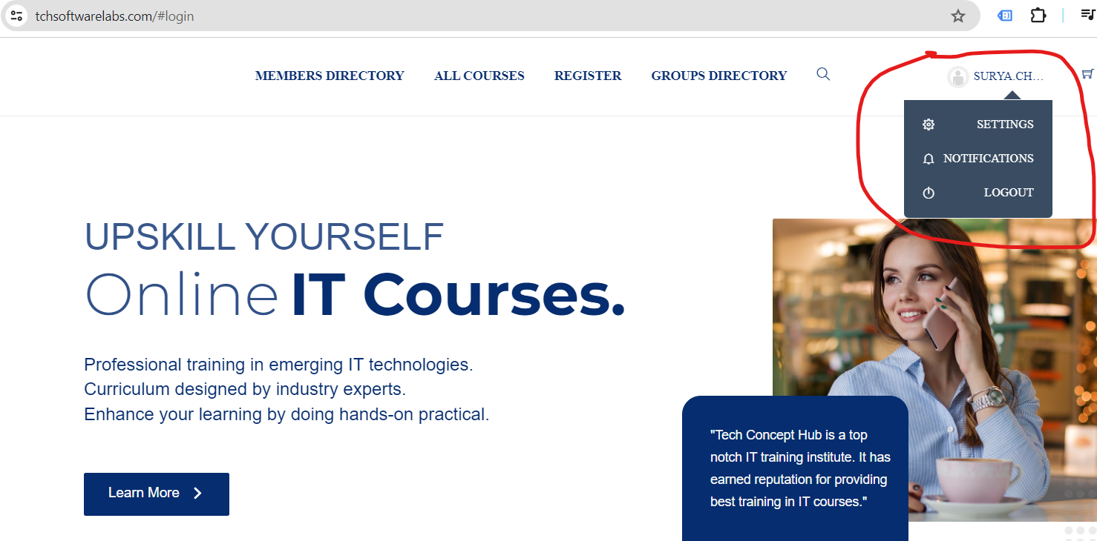

**Whereas in WPLAM demo, COURSES is also coming.**

**Same should come for me also.**

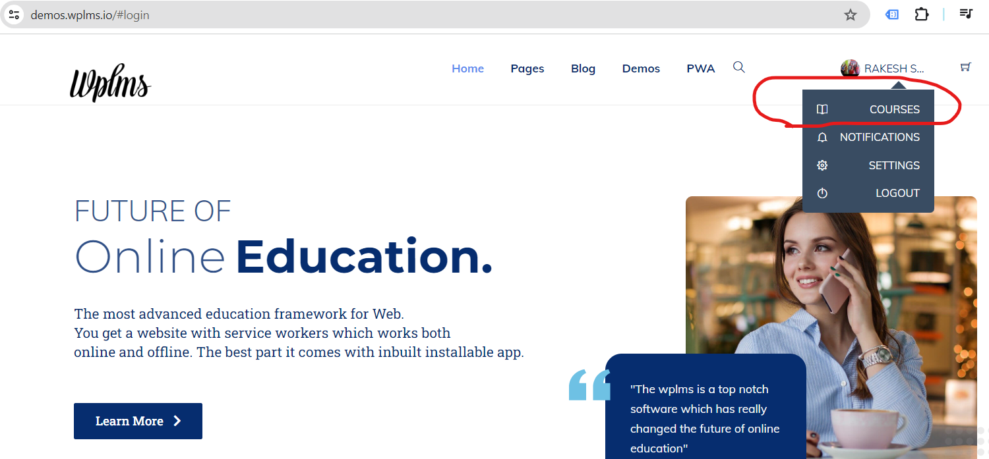

**Issue 2: Top menu of my website is not similar to demo.**

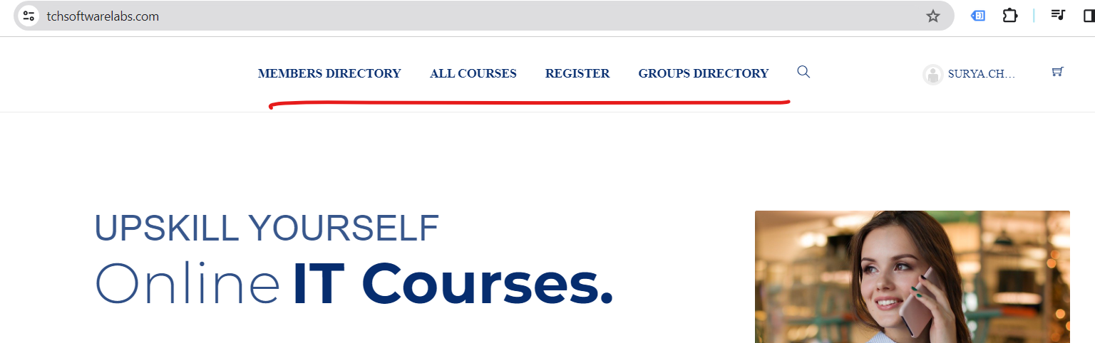

**Whereas in WPLMS demo, become comes. Same should have come for me also.**

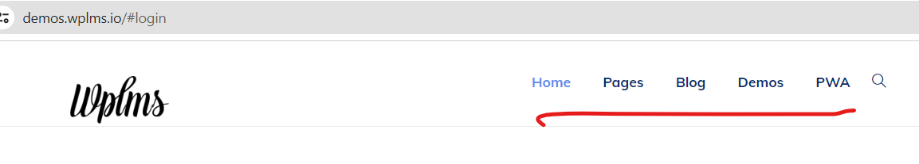

**Issue 3: Footer of my website is broken.**

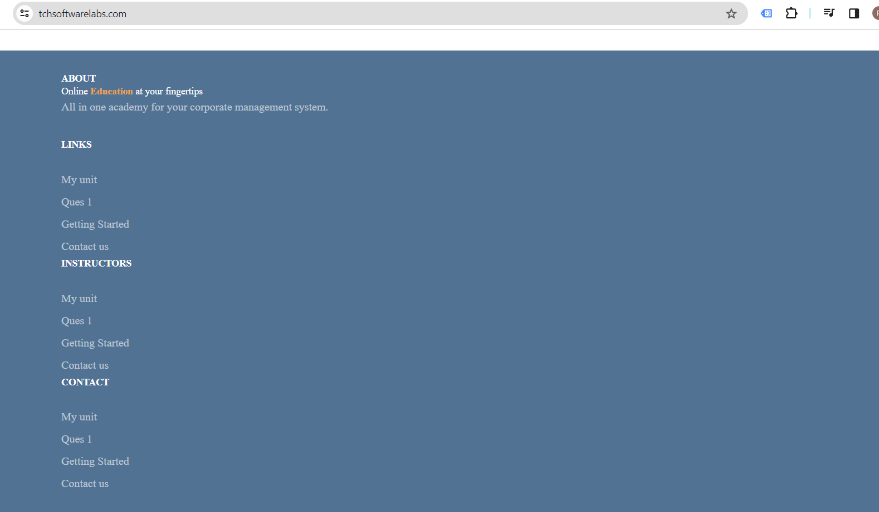

**Whereas in WPLMS demo, below comes. Same should come for my me also.**

